Exp.No:32
32. Morphological operations based on OpenCV using Closing technique.

Aim:
To perform morphological Closing operation on an image using OpenCV.
Procedure:
- Read the input image.
- Create a structuring element.
- Apply dilation followed by erosion.
- Display the original and closed images.
- Save the output.
Program:
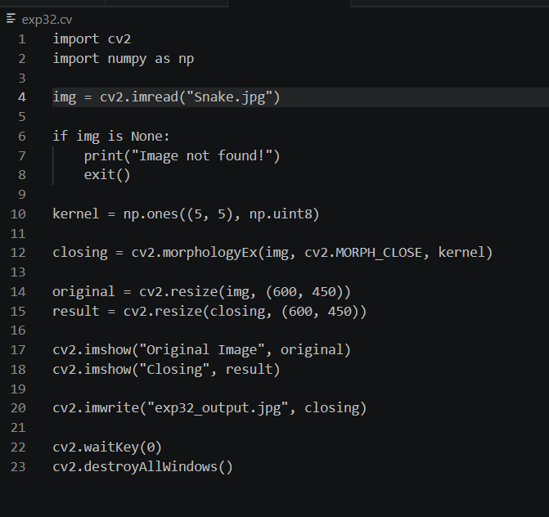

Input:
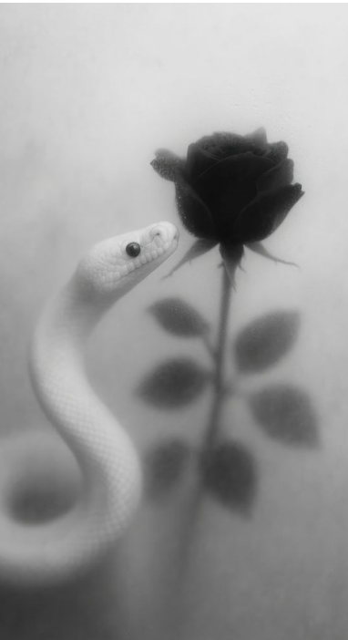
Output:
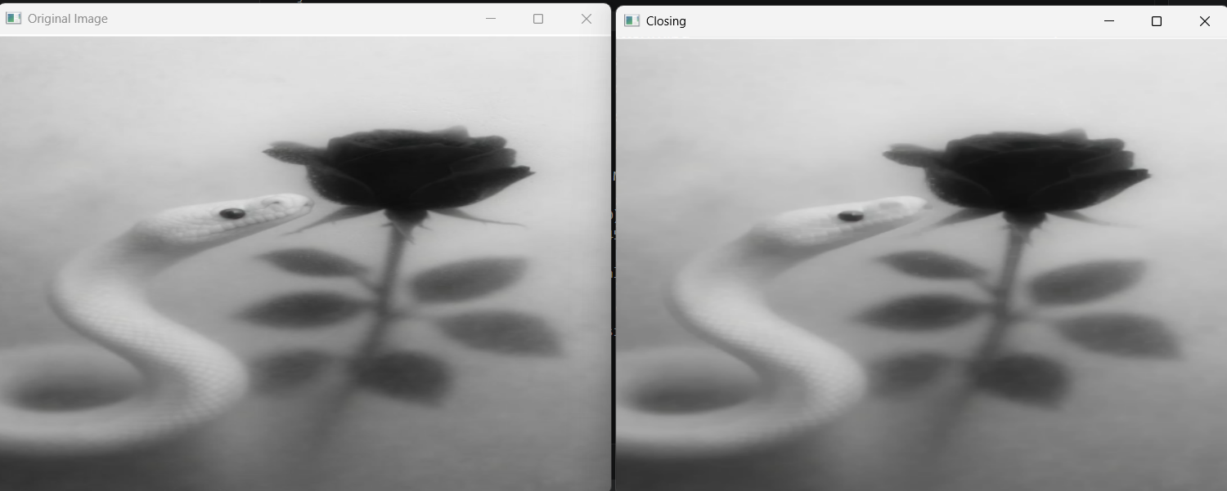

Result:
The morphological Closing operation was successfully performed on the image.

